Oracle Access Management WebGate (IDM Single Node) - Blueprint Information

# Overview

The purpose of this document is to describe the Oracle Access Management WebGate blueprint (as part of the IDM Single Node blueprint) in detail. The goal of the blueprint is to allow for provisioning and configuration of a single node Oracle Access Management WebGate (OAM WG) instance in an automated and repeatable fashion.

The following components and versions are installed as part of the OAM WG instance:

1. OAM WG Release 10.1.4.2.0.05 BP 05

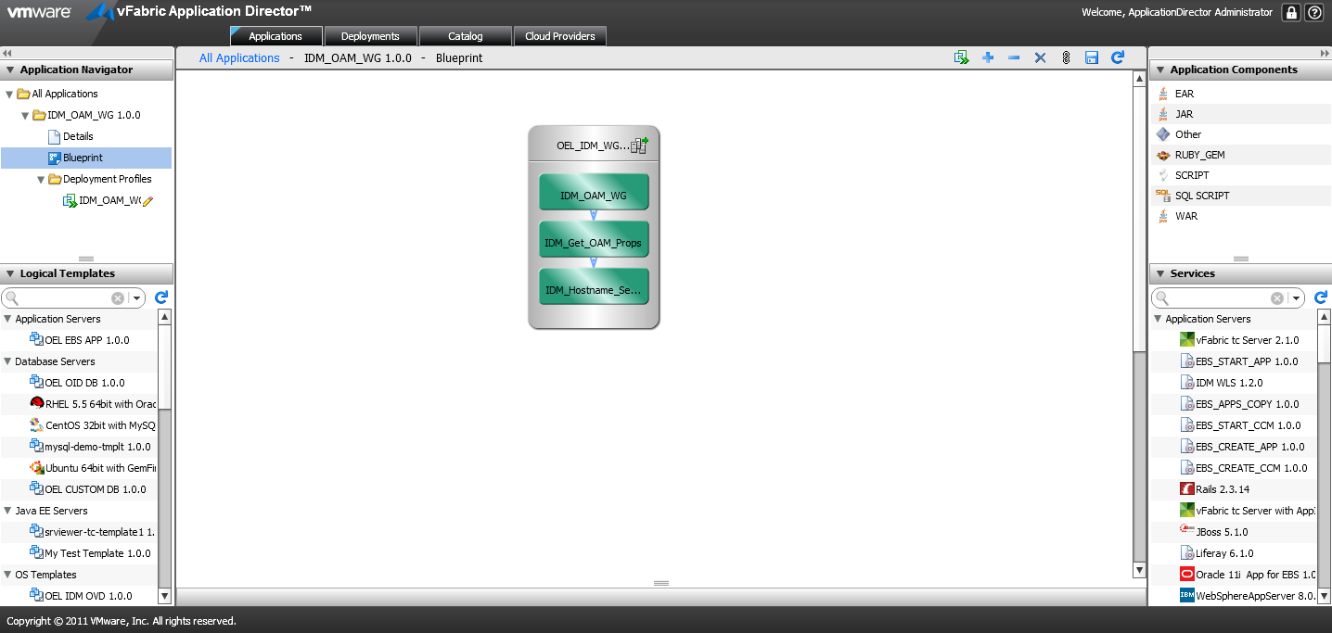

# High level BLUEPRINT Design

Conceptually, the blueprint design consists of the tasks described below. These tasks are listed in chronological order:

1. Setup Host Name
2. Retrieve Oracle Access Management (OAM) Properties
3. Install OAM WG Release 10.1.4.2.0.05 BP 05

## Files

You will need access to create the following file repository that contains the necessary installers and configuration files needed. We will refer to this repository as the “Mount Point Location” in this document.

$MOUNTPOINTLOCATION/IDM:

oam/ Installation and configuration directory of OAM

oam_101401/ Installation packages of OAM 10.1.4.0.1

oam_101420_patchset/ Installation upgrade patches of OAM 10.1.4.2.0

oam_101420_BP / Installation bundle patches of OAM 10.1.4.2.0

gcc_lib/ GCC libraries required by OAM installation

Templates/ OAM WG installation and configuration templates

wg_install_options.txt OAM WG silent installtion response file Template

simpleCA.tar OAM Certificate package

You will also need below files to configure the scripts and services within this blueprint. Please refer to the following sections for details and their corresponding script/service.

IDM_Hostname_Setup_INSTALL.txt

IDM_Get_OAM_Props_INSTALL.txt

IDM_OAM_WG_INSTALL.txt

IDM_OAM_WG_CONFIGURE.txt

## Setup Host Name

The “Setup Host Name” task sets the hostname for the machine that’s provisioned. It’s defined as a blueprint service.

Properties:

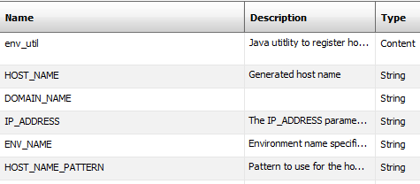

Actions:

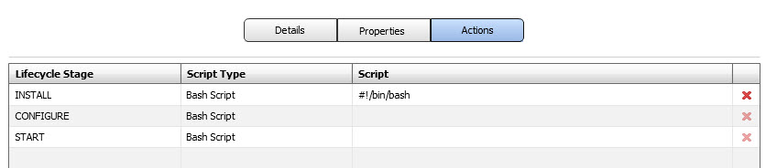

Install Script:

Please refer to file **IDM_Hostname_Setup_INSTALL.txt** to copy the script as the INSTALL Bash Script.

## Retrieve Oracle Access Management (OAM) Properties

The “Retrieve Oracle Access Management (OAM) Properties” task retrieves the OAM information that OAM WG needs to connect to from Perforce. It’s defined as a blueprint service.

Properties:

Service Definition

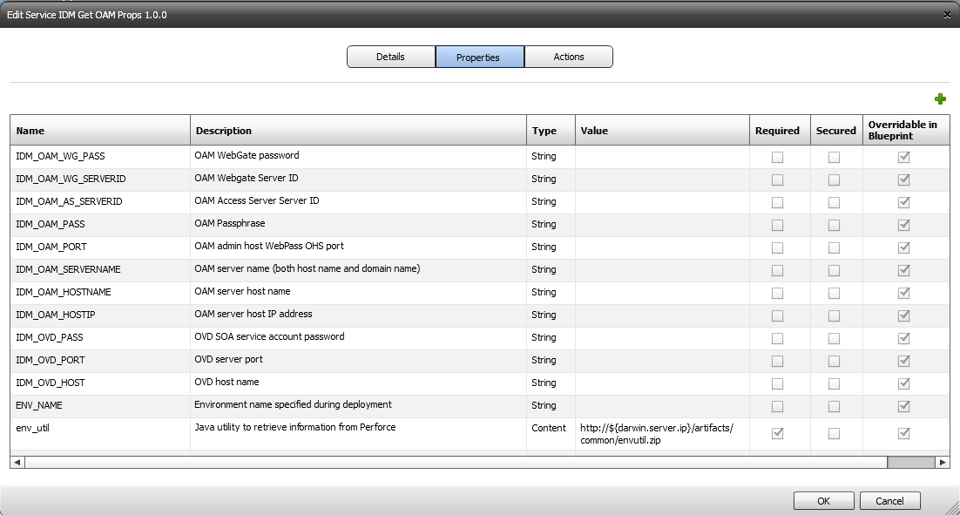

Blueprint Definition

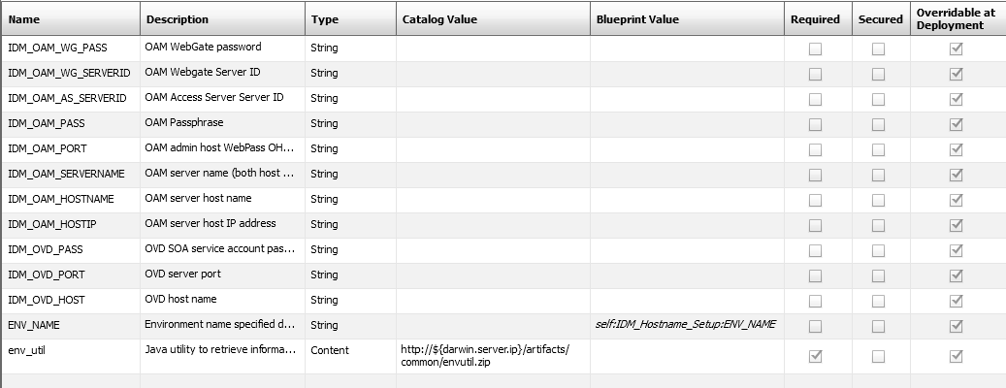

Actions:



Install Script:

Please refer to file **IDM_Get_OAM_Props_INSTALL.txt** to copy the script as the INSTALL Bash Script.

## Install OAM WG Release 10.1.4.2.0.05 BP 05

The “Install OAM WG Release 10.1.4.2.0.05 BP 05” task installs an OAM WG server instance. It’s defined as a blueprint service.

Properties:

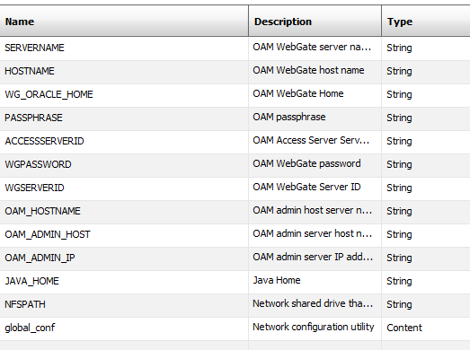

Actions:

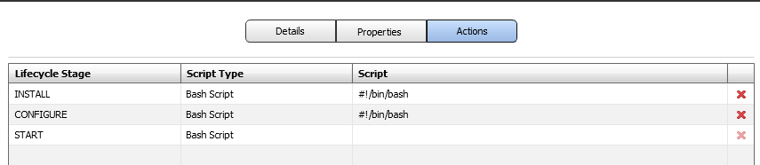

Install Script:

Please refer to file **IDM_OAM_WG_INSTALL.txt** to copy the script as the INSTALL Bash Script.

Please refer to file **IDM_OAM_WG_CONFIGURE.txt** to copy the script as the CONFIGURE Bash Script.